Module Code: COS1511
Assessment: Assignment 2
Student Number: 69234175
Name: Jaymeen Patel

Question one

- void check (int num1, float num2)
- float mult (float num1, float num2)
- void time (int &s, int &m, int &h)
- int countChar (string s, char c)

Question two

- The functions cannot be nested, so to fix this we can use referencing parameters for both functions. The function type is int so it has to return an integer value, code “return 0;” can be used to fix this error.

- There is nothing returned after the result variable is assigned, to fix this we can add the code “return result;”.

- The closing brace is in the wrong place, it should be after the “n * computeProd(n - 1);” and the 1st return should be a one, otherwise the output will only display zero because everything will be multiplied by zero. There should also be a 2nd return after the else statement, the correct code should be “return n * computeProd(n - 1);” otherwise the output will only return one.

- Float A is already declared so there is no need to declare it again inside the function, to fix this we just have to delete the 2nd declaration inside the function.

- The function is returning a value but the function type is void, to fix this we need to change the void function type to an int function type.

- There is no error within this code.

Question three

- int calculateCube(int number)
{ int ans;
Ans = number * number * number;
Return ans; }

- void calcSumAndDiff(int n1, int n2, int&sum, int&diff)
{ sum = n1+n2;
if(n1>n2)
diff = n1-n2;
else
diff = n2-n1;}

- void rectangle(int w, int h)
{ int i,j;
for(i=1;i<=h;i++)
{ for(j=1;j<=w;j++)
{ if (i == 1 || i == h || j == 1 || j == w)
cout << "*";
else
cout << " ";
}
cout<< endl;
} }
- float computePrice(char pSize, int numToppings)
{ switch(pSize)
{
case 'S': return 50 + 5.50*numToppings;
case 'M': return 70 + 6.50*numToppings;
case 'L': return 90 + 7.50*numToppings;
}}

Question four

#include <iostream>

using namespace std;

void inputData(string &name, string &addr1, string &addr2, string &postalCode)
{

cout<<"Enter name"<<endl;
getline(cin, name, '\n');

cout<<"Enter address 1"<<endl;
getline(cin, addr1, '\n');

cout<<"Enter address 2"<<endl;
getline(cin, addr2, '\n');

cout<<"postal code"<<endl;
getline(cin, postalCode, '\n');
}

void displayData(string &name, string &addr1, string &addr2, string &postalCode)
{ // string name, addr1, addr2, postalCode;

cout<<name<<endl;
cout<<addr1<<endl;
cout<<addr2<<endl;
cout<<postalCode<<endl;
}

int main()
{string name, addr1, addr2, postalCode;

inputData(name, addr1, addr2, postalCode);

displayData(name, addr1, addr2, postalCode);
return 0;
}
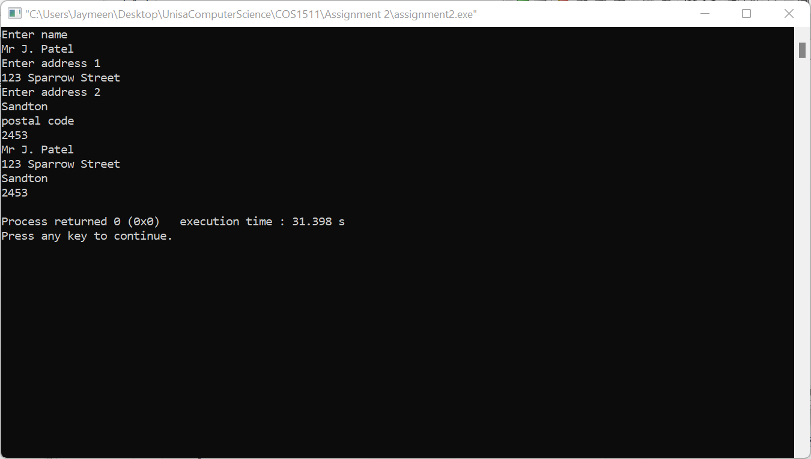

Question five

#include <iostream>

using namespace std;

int getScore()
{int testScore;//testScore2,testScore3,testScore4,testScore5;

cout<<"Enter test score ";
cin>>testScore;
cout<<endl;

while (testScore < 0 || testScore > 100)
{
cout << "You have entered an invalid number\n";
cout << "Please enter a number from 0-100 for each test score: ";
cin >> testScore; //>> testScore2 >> testScore3 >> testScore4 >> testScore5;
}
return testScore;
}

int findLowest (int &testScore1,int &testScore2,int &testScore3,int &testScore4,int &testScore5)
{ int lowest=100;

if(testScore1<lowest)
{
lowest = testScore1;
}
if(testScore2<lowest)
{
lowest = testScore2;
}
if(testScore3<lowest)
{
lowest = testScore3;
}
if(testScore4<lowest)
{
lowest = testScore4;
}
if(testScore5<lowest)
{
lowest = testScore5;
}

return lowest;

}

float calcAverage(int &testScore1,int &testScore2,int &testScore3,int &testScore4,int &testScore5)
{
int lowestnum, sum;
float average;

lowestnum = findLowest(testScore1,testScore2,testScore3,testScore4,testScore5);
sum = testScore1 + testScore2 + testScore3 + testScore4 + testScore5 - lowestnum;

average = sum / 4;
cout.setf(ios::fixed);
cout.precision(2);

cout<<"Average of test scores after dropping lowest number is "<< average<<endl;

return average;
}

void displayOutput(int &testScore1,int &testScore2,int &testScore3,int &testScore4,int &testScore5)
{

cout<<"average is "<<calcAverage<<endl;
cout.setf(ios::fixed);
cout.precision(2);

}

int main()

{
int testScore1,testScore2,testScore3,testScore4,testScore5;

testScore1 = getScore();
testScore2 = getScore();
testScore3 = getScore();
testScore4 = getScore();
testScore5 = getScore();
calcAverage(testScore1,testScore2,testScore3,testScore4,testScore5);

displayOutput;

return 0;
}

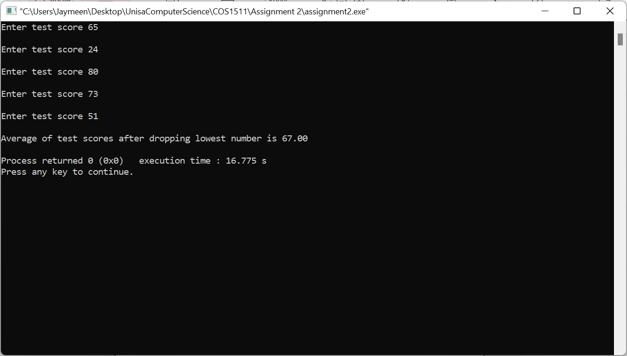

Question six

#include <iostream>

using namespace std;

void getData(int &theHeight, int &theWidth, int &theLength)
{
cout << "Please enter the height of your room: ";
cin >> theHeight;
cout << endl << "Please enter the width of your room: ";
cin >> theWidth;
cout << endl << "Please enter the length of your room: ";
cin >> theLength;

}

int calculateVolume(int &theHeight, int &theWidth, int &theLength,int &ans)
{
// int ans;
ans = theHeight*theLength*theWidth;
return ans;

}

void displayOutput(int &theHeight, int &theWidth, int &theLength,int&ans)
{

cout<<"The volume of a room with height "<<theHeight<< " , width " << theWidth << " and length " << theLength << " is "<< ans<<endl;
if (ans < 100) {
cout << "Size: small" << endl;
}
else if (ans > 100 && ans < 500) {
cout << "Size: medium" << endl;
}
else {
cout << "Size: large" << endl;
}

}

int main()
{ int theLength, theHeight, theWidth, ans;

getData(theLength, theHeight, theWidth);
calculateVolume(theLength, theHeight, theWidth, ans);
displayOutput(theLength, theHeight, theWidth, ans);
return 0;
}
